**Date Field Problems**

Date of Birth and ID Expiration Date will have the same type of issues.

When typing in 07201986 as the birthday and this is the formatting issue

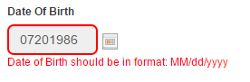

When typing day 32 in Date of Birth, the pop-up message doesn’t make sense

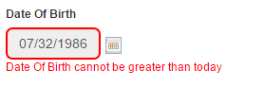

The same message happens when typing in a month greater than 12

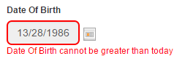

1986 wasn’t a leap year, but the day was allowed to be inputted in the text field.



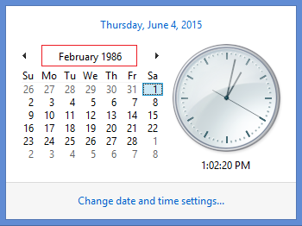

The Date Picker only allows for the arrows to go back month by month, and sense the calendar is for Date of Birth it’s too many clicks for most people.

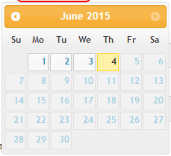 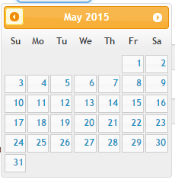

If someone is 28 year old, and the date picker was used to input the birthday; it would take roughly 336 clicks. There are other date pickers that allow for year to year transition.

**Doc Type**

This is minor

This person filling out this form is applying for a document/certificate; they aren’t applying for an order. Rather than confusing the person couldn’t it by Document Type or Certificate Type rather than Order Type? The clerk processing it can see it as Order Type, because to them it’s an order.



**Differences in Browsers Birth Date**

In Internet Explorer and in Firefox I processed an order, but the Date of Birth Field didn’t correct me. In Chrome I wasn’t able to click on the submit button, because it would give me an error message. When I clicked on the submit button here It processed through.

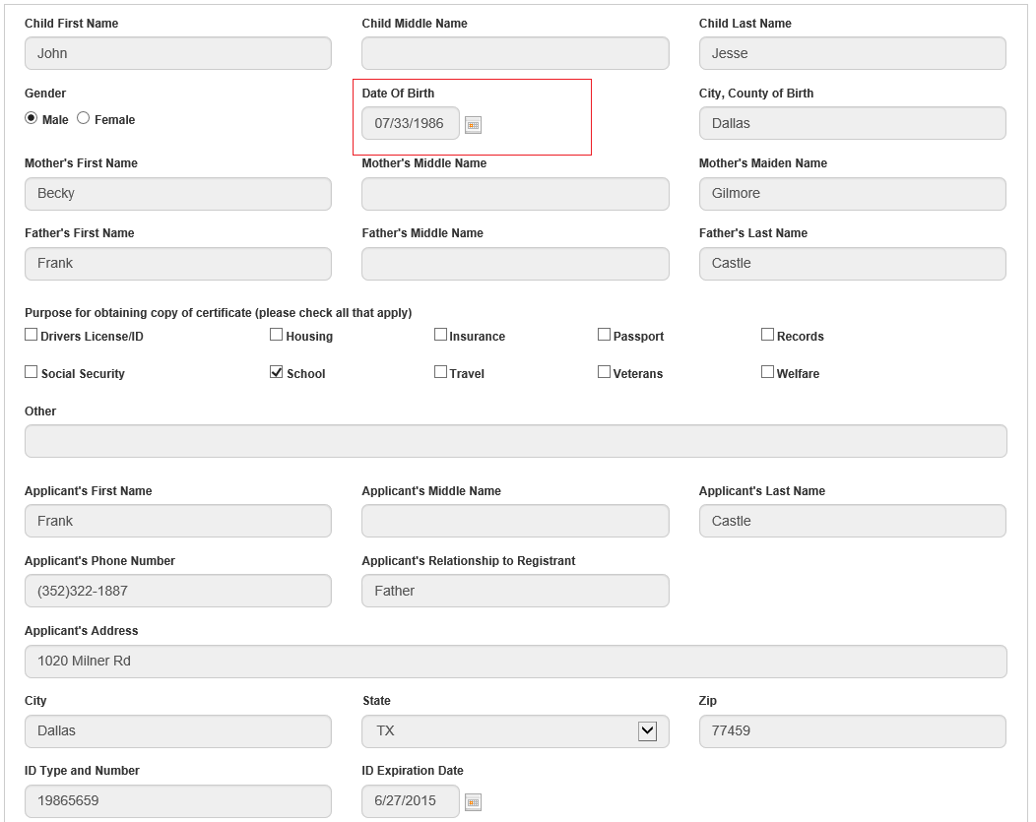

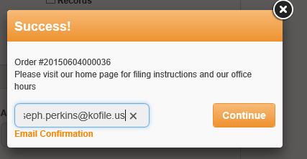

**Email**

When processing the Order an Email Confirmation was requested, and this is what’s received.

**Hello,**

Thank you for ordering Birth or Death Certificate online. Please visit our website <http://www.huntcounty.net/> for filing instructions and our office hours.

Vital Certificates Application Order#: 20150604000038 . In order to expedite the process, please have this Order# ready when visiting our office.

Regards,

Jennifer Lindenzweig, Hunt County Clerk

This link that is provided only goes to Hunt County Home page. If this is your first time to the site it can be confusing trying to find the office information and filing information.

Using this link would direct them to the County Clerks page with the address and hours: <http://www.huntcounty.net/index.aspx?nid=760>

This link takes to the Birth and Death Records page that has office location and filing information. <http://www.huntcounty.net/index.aspx?nid=164>

**Submitting the Order**

Once you click on the Submit button, the next screen that you see is this.

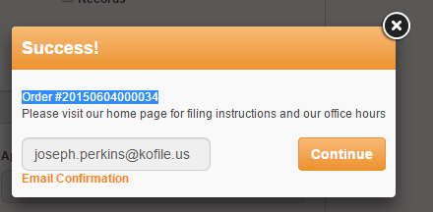

There is no middle screen to have the user check their information one last time to verify if everything is correct.

**ID Type and Number textbox**

There’s issues with the ID Type and Number textbox. When entering some information that would in theory be correct, but the system isn’t going to accept it. The error message is also wrong, because it was less than 50 characters.

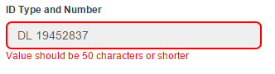

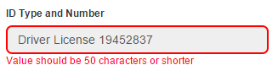

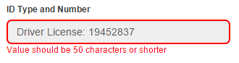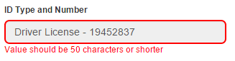

Typing in a number gets the error message to go away.

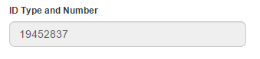

The title of the text field says that there should be an ID Type, but by excluding it and the text field accepts it as the only valid value.

**Language**

Almost every form filled out today would have Spanish at least on the page, either next to the English word or maybe have a radio button that when click switch everything over to Spanish.

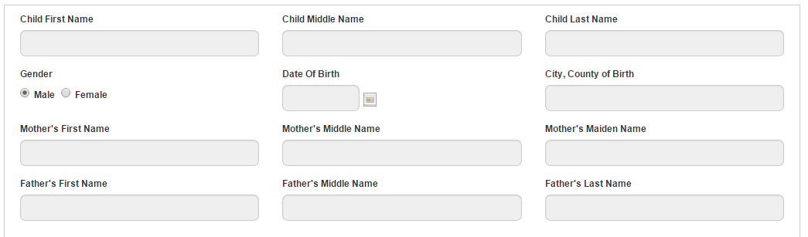

**Layout**

When you first see the form all the information is presented like this.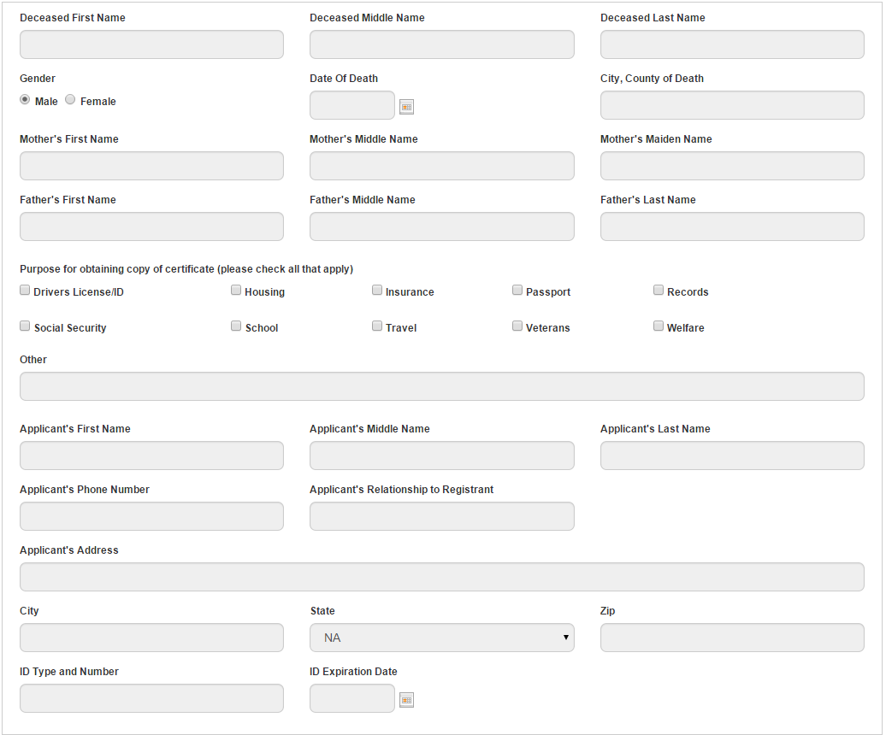

Couldn’t there be some lines that are blocking off sections, so that it’s easier to know whose Date of Birth is needed in that field. Giving that there is an Other textbox in the section where you check “why you’re obtaining the certificate”, it could be confusing what that Other textbox is referring to if there isn’t something to group the section off. Having boxes to block off text fields helps the user process what information is needed in each field.

It could look something like this

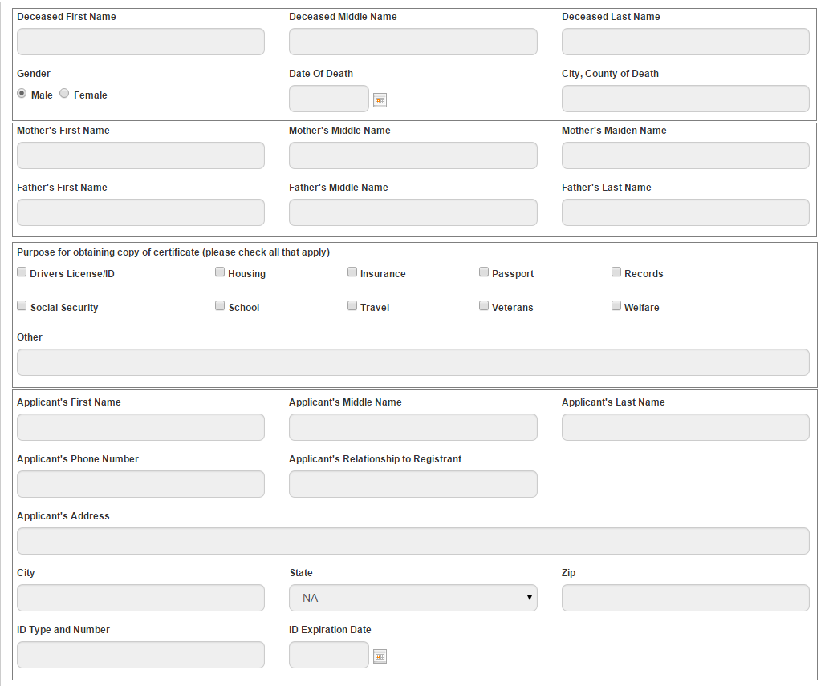

**Length**

There’s some problems with the length of some of these fields.

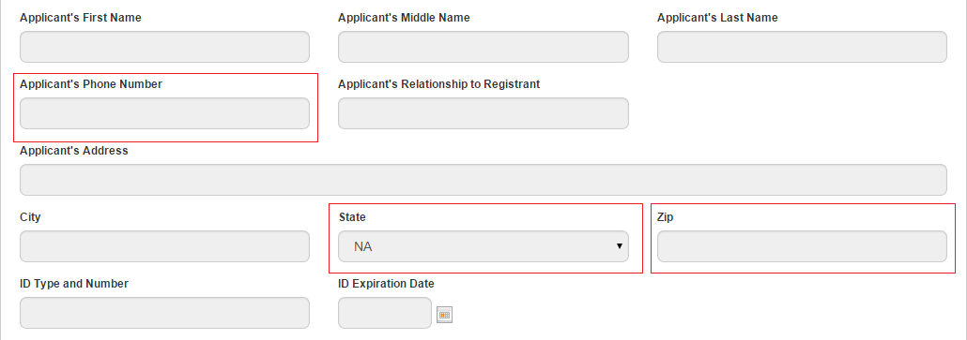

These field has a maximum length associated with them, and if you fill them out to the maximum length there is so much empty space left.

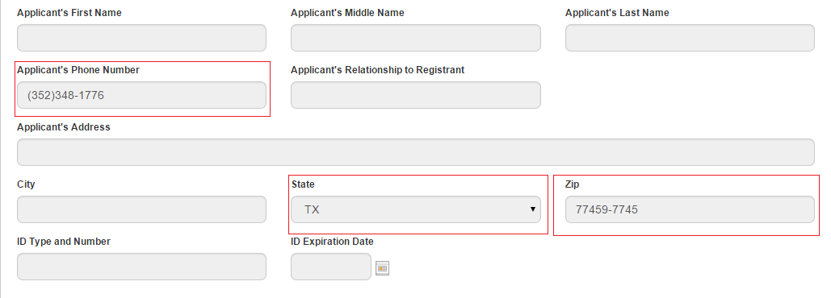

The Phone Number field might be a whatever, but the State and Zip is the big offender. Most electronic forms have these fields closer to their actual maximum length. Especially for the State section which is a drop down box that’s only using a 2 letter designation for states.

**Mandatory Fields**

When first landing on the site this is how the form appears.

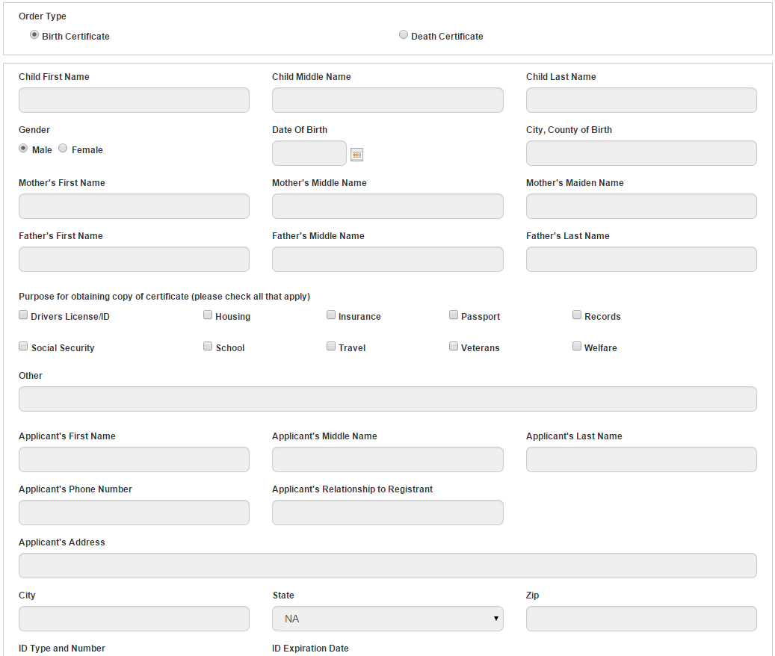

How does a user initially know what is mandatory vs. what’s not mandatory. Usually forms have the  next to each field that is mandatory.

Currently the user is clicking into Child’s First Name textbox.



But once the user clicks out of the textbox, there is no message that is says Child First Name is mandatory.

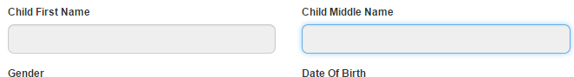

Once the user clicks the Submit button, then the user receives what’s mandatory vs. what’s not.

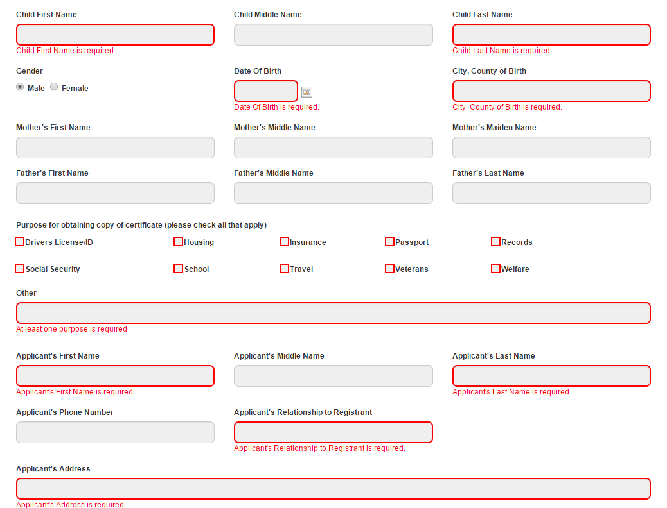

*If you’ve typed in any information and refresh the screen or navigate away from the screen and come back, the information is gone.

*Separately, why are all of the “purpose” check boxes highlighted for required info?  This might confuse some into thinking they have to select all of them or some such.  This is a lot of unnecessary red to throw at the customer.

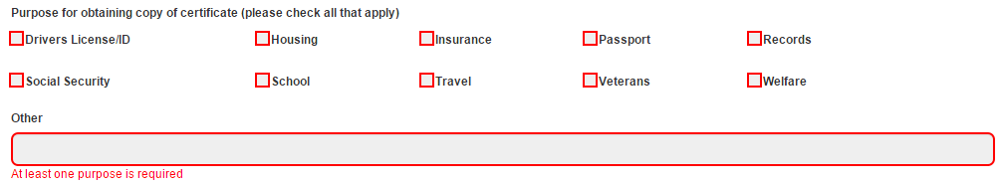

*If I enter a space on the *other* field for “purpose” that satisfies the requirement.

*The dob field should fill in /’s for you.

*The date cannot be greater than today, but there is no cap on how old the birth or death is outside of entering in 4 digits for the yyyy.  Theoretically, I could request documents dating back to the 11th century.  Putting a cap on the other end helps to reduce the margin of error for those afflicted with fat finger.

*If I mess something up in entering info into the date field, the error message comes up upon the very first entry and throughout the entire process.  This may not be a bug, but certainly bugs me as a customer.

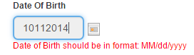

OK, I get it.  Let me delete this information and start again.

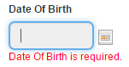

Yeah, no kidding…

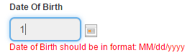

I’m typing here!  Leave me alone, unnecessary red error message.  At least let me finish first.

*MM is capitalized and the rest is not.

*When filling out address information and tabbing to state, I just click the first letter of my state until it scrolls to the desired state.  If you type any other letter than the one you wanted to, then try to click the desired letter, there is no response.  For example, I clicked the R because it’s right next to T for Texas.  It immediately scrolled to RI.  I see that and click T to scroll through the T’s, but there is no response whatsoever.  Whatever you type first, it is going to stick on.

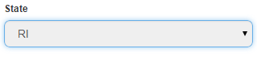

*Zip code should not give error message before completion.  Also, the only people that know the last 4 digits of the zip code work for the post office.

